Norauto Pepper on Stage

# Controls

* turn on pepper router
* connect to Pepper router with your pc
* turn on pepper by pressing the chest button
* when pepper wakes up, press the chest button. She will say the IP address. note it down
* surf to <http://IPADDRESS/apps/NorautoStageControls/>

192.168.10.64**/apps/NorautoStageControls/**

You will now see the controls:

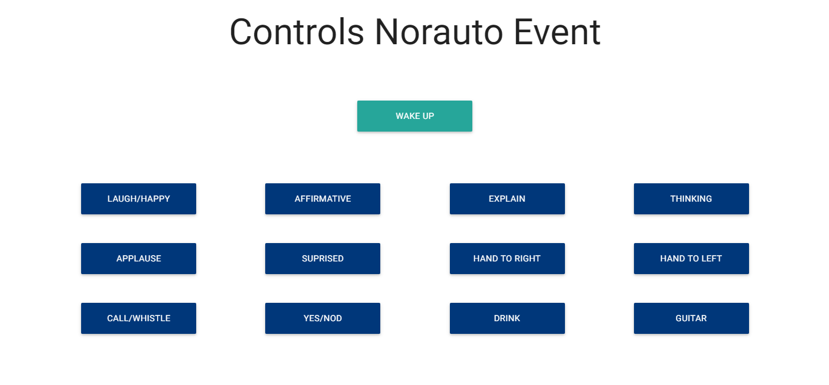

# Running the application

* start “**putty”** on your computer
* connect to pepper with putty
* Start the script:

